;

**ISM 6217 – Database Management Systems**

**Fall 2017**

**Class Assignment 4**

**5 points**

**Task: Table Creation and Management**

1. Complete all the hands-on exercises from Chapter 3,page 97 of the textbook. Paste the SQL and results. Perform **Desc** command on the tables to validate your answers and paste those results too.

**Answer to Question 1**

**create table CATEGORY (CatCode Varchar(2), CatDesc Varchar(10));**

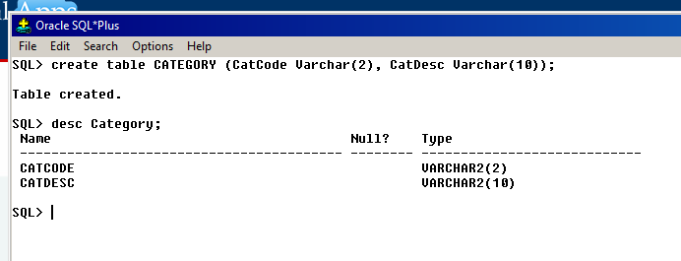

**Answer to Question 2**

**create table Employees (Emp# Number(5), Firstname Varchar(10), Lastname Varchar(10), Job_Class Varchar(4));**

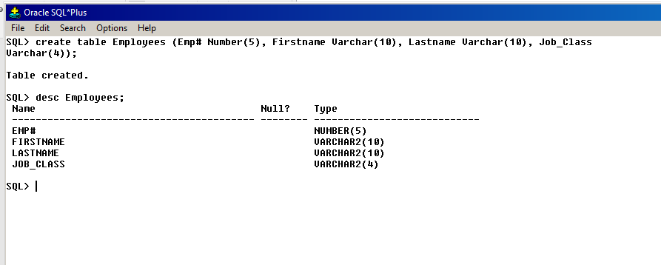

**Answer to Question 3**

**Alter table Employees add (Empdate Date Default Sysdate, Enddate Date);**

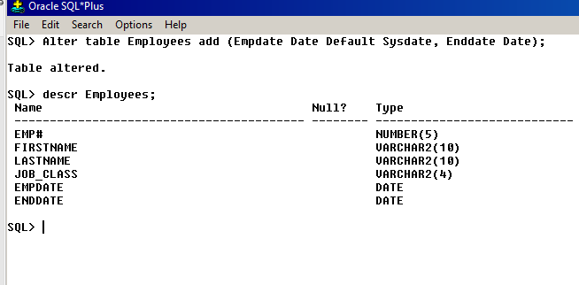

**Answer to Question 4**

**Alter table Employees modify (job_class VarChar(2));**

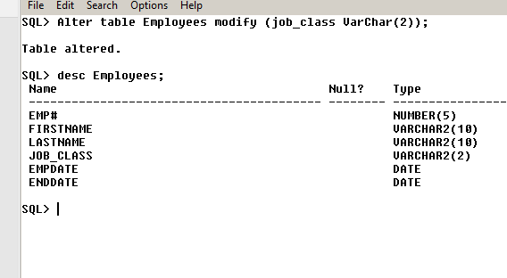

**Answer to Question 5**

**Alter table Employees drop (enddate);**

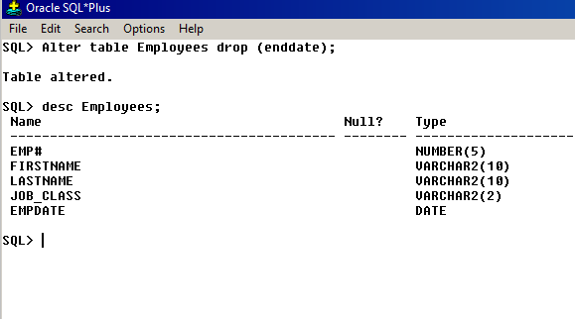

**Answer to Question 6**

**Rename Employees to JL_EMPS;**

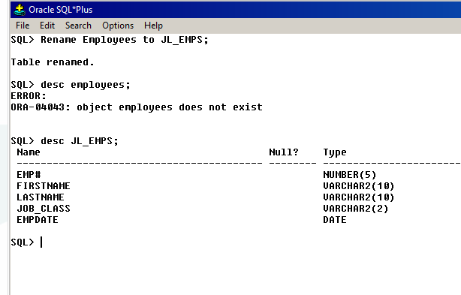

**Answer to Question 7**

**Create table Book_pricing as (select ISBN, Cost, Retail, Category from Books);**

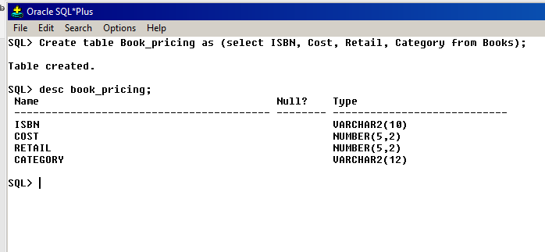

**Answer to Question 8**

**Alter table Book_pricing set unused (category);**

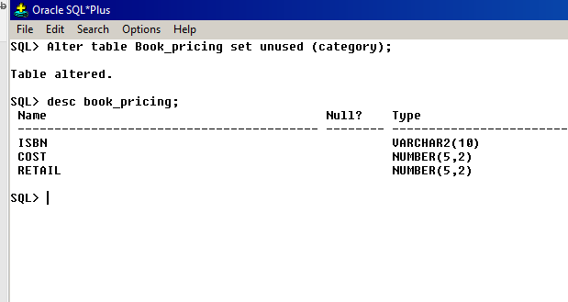

**Answer to Question 9**

**Select * from Book_pricing; --- to see all rows of the table before truncating**

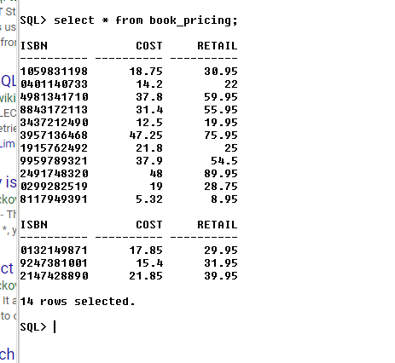

**Answer to Question 9 contd.**

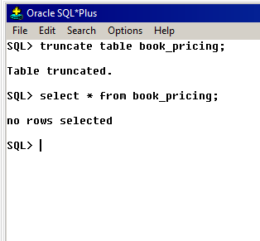

**Answer to Question 10**

**Drop table Book_pricing purge;**

**Drop table JL_EMPS;**

**flashback table JL_EMPS to before drop;**

